How to access HMH Ed Learning Platform
- Log onto a computer
- Open an internet browser. Google Chrome or Microsoft Edge
- Search ASD20 and click Logins
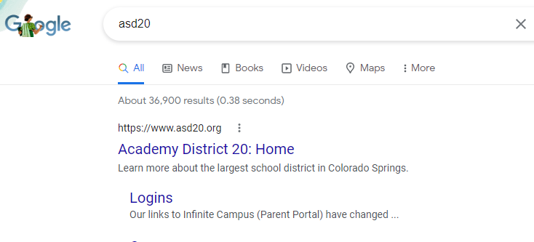
- Under the large blue banner, click the tab that says Students
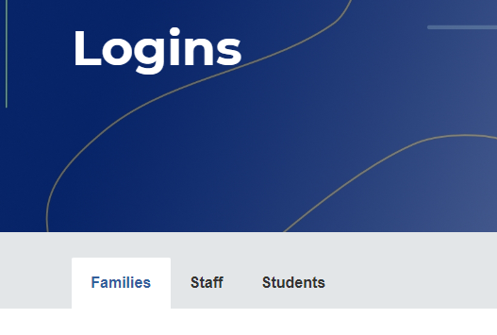
- Once on the Students tab, scroll to find Clever and click Login
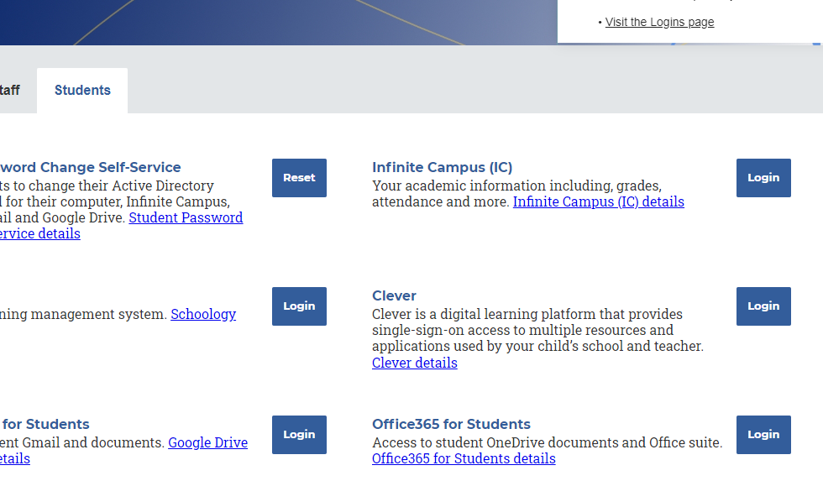
- Login using your district email student#@msa.asd20.org
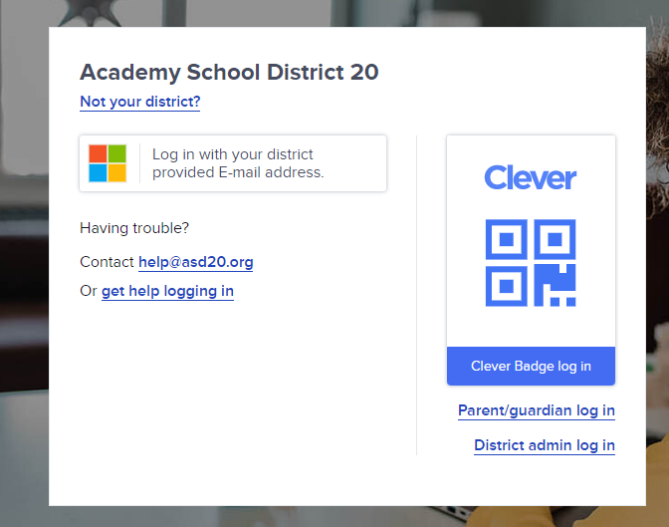
- Click on HMH Learning Platform Ed
